APPENDIX 1

SUBMISSION CHECKLIST FOR DEVELOPMENT APPLICATIONS FOR SITES
WITH URBAN DESIGN GUIDELINES/ WITHIN URBAN DESIGN AREAS

Project Description:

I Plan Presentation and Site Context Information: |  |  |  | Yes |  |  |  |  | NA
 |  |  |  | (Please tick the appropriate box)
- Drawings are clear and legible (e.g. adhering to the standard drawing conventions, clearly annotated, and showing the relevant extent of works)

- All additions, alterations and amendments are presented clearly using the standard drawing conventions.
- Clear annotation and reference of site context (e.g. adjacent road names, development names or a geo-referenced model).
II Critical Items for Grant of Provisional Permission

Urban Design Guidelines and Streetblock Plans
Please check the box that applies to your proposal:
- Urban Design Areas
- Bras Basah.Bugis Urban Design Guidelines and Plans
- Downtown Core Urban Design Guidelines and Plans
- Jurong Gateway (Jurong Lake District) Urban Design Guidelines and Plans
- Museum Urban Design Guidelines and Plans
- Orchard Urban Design Guideline and Plans
- Paya Lebar Urban Design Guidelines and Plans
- Punggol Digital District Urban Design Guidelines and Plans
- Singapore River Urban Design Guidelines and Plans
- Design & Submission Guidelines for Implementation of Singapore River Promenade
- Woodlands Central Urban Design Guidelines and Plans
- Other Urban Design Areas
- Not Applicable

- Areas where Streetblock Plans apply
Name of Streetblock:

- Urban Design Guidelines and Plans issued as part of Government Land Sales Conditions, Outline Planning Permission/ Outline Application Advice or otherwise conveyed by the Urban Redevelopment Authority
- Does your proposal comply with all relevant Urban Design Guidelines / Streetblock Plans? | Yes |  | No |  |  |  |  | NA
 | (Please tick the appropriate box)
(If you have sought approval for deviation before, please select "No")

- If any of the following items are not in compliance without justification as per Urban Design Guidelines and Plans or Streetblock Plans, the UD of the entire submission will not be evaluated.
- Building Height
- Building Setback
- Vehicular Ingress/ Egress Points (including Service Access)
Vehicular ingress / egress points (including service access) in accordance with existing access points or the guidelines stated above

- Car/ Coach Parking Provision
Car/ coach parking provision in accordance with LTA’s prevailing Code of Practice or the guidelines stated above.

- If the following items as required in the applicable Urban Design Guidelines and Plans or Streetblock Plans are not provided, please include justification. Failing which , the UD of the entire submission will not be evaluated.
 | Yes |  | No |  | NA
 | (Please tick the appropriate box)
- Covered Walkway
- Through Block Link
- Underground Pedestrian Link
- Elevated Pedestrian Link
- Public Space
- If the following information is not provided, related items of the proposal (e.g. 1st storey plan) will not be evaluated.
 |  | Yes |  | No |  | NA
 |  | (Please tick the appropriate box)
- Pedestrian Walkway
- Covered and open walkway are directly adjacent to each other and on the same level.
- Where the open / covered walkway intersects with the vehicular driveway, there is no level difference.
- Open/ covered walkway remains seamlessly connected, without any step(s).
- Level difference between the open / covered walkway and the development accommodated within the development and not within the covered walkway.
- Overall / clear width and soffit heights / drop panel of the covered walkway comply with guidelines.

- Platform levels/ spot levels and ramps with gradients of the covered and open walkways of the development and adjacent developments have been indicated to show how the level differences (if any) have been addressed.
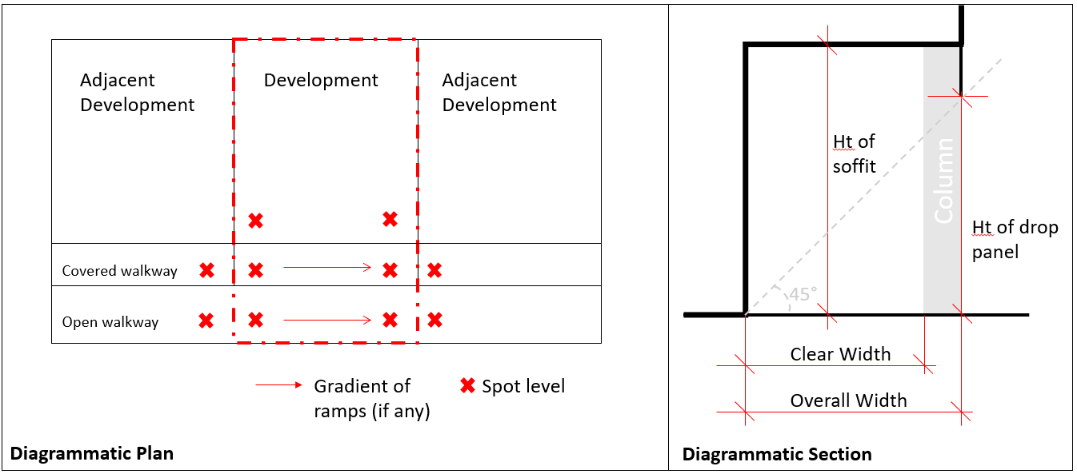
- Screening for M&E and Car Park
Please note that screening for exposed M&E services and above ground carparks is mandatory. Refer to URA/PB/2022/01-CUDG: Screening of Mechanical and Electrical Services and Car Parks

- The locations of the exposed M&E services (e.g. aircon condenser units, M&E spaces on rooftop, sky terraces or 1st storey) are shown.

- All M&E services and carparking areas visible externally are visually well screened on the top and all sides (a minimum depth of 150mm is provided on the top and on all sides for the incorporation of screening elements).
- Activity Generating Uses
Activity Generating Uses are provided and shown as required in the respective Urban Design Guidelines or Streetblock Plans.

Signed By: (QP’s name)

Amendment 1 (Jun 2023) – A list of Urban Design Areas can be found at https://www.ura.gov.sg/maps/?service=SBUDCM
Amendment 2 (Jun 2023)
PACS (URA/PB/2018/01-DCG) is a service which allows applicants to pre-consult URA on the application of development guidelines on development proposals for specific sites before detailed plans are finalised. Further details can be found at www.ura.gov.sg/Corporate/Guidelines/Circulars/dc18-01
PACS (URA/PB/2018/01-DCG) is a service which allows applicants to pre-consult URA on the application of development guidelines on development proposals for specific sites before detailed plans are finalised. Further details can be found at www.ura.gov.sg/Corporate/Guidelines/Circulars/dc18-01
PACS (URA/PB/2018/01-DCG) is a service which allows applicants to pre-consult URA on the application of development guidelines on development proposals for specific sites before detailed plans are finalised. Further details can be found at www.ura.gov.sg/Corporate/Guidelines/Circulars/dc18-01

